CREATING RAID 0 IN CENTOS 7

RAID 0 is not fault tolerant but it has some advantage

→ it is high performance
→ no space will be wasted
→ reading and writing speed will be Fast

Setting up RAID 0 in Virtual Machine :

Requirements:
→ Virtual Machine
→ Two disk
→ internet connection
→ a static ip address (in case you want to ssh the server)

STEP 1:
Adding two 20GB disk in the centos7 Virtual machine.

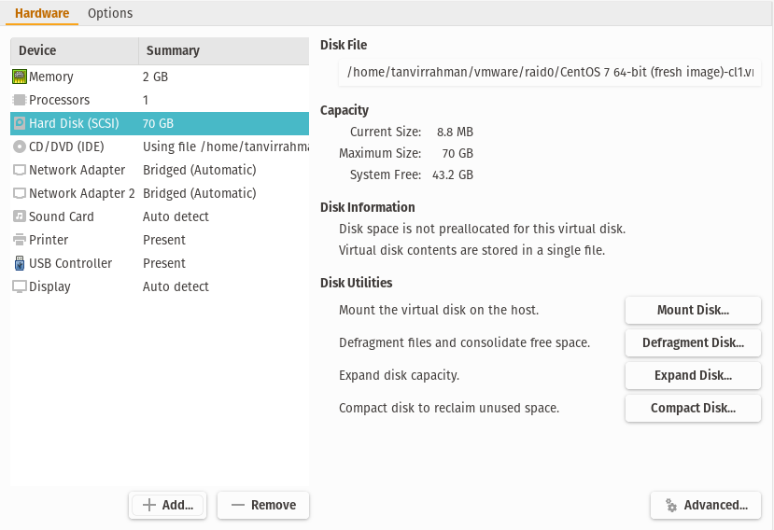

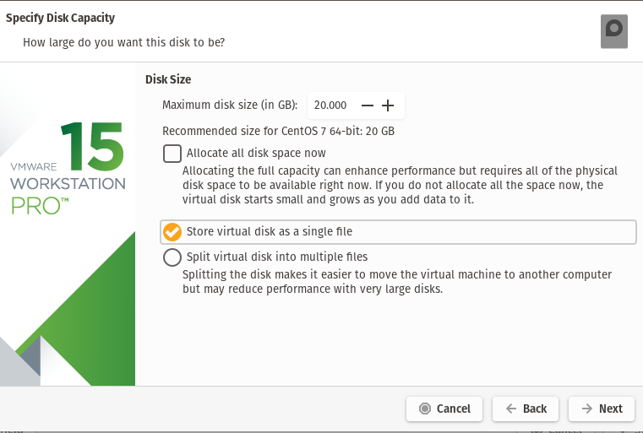

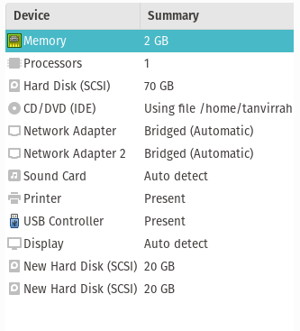

STEP2:
Boot the machine.

STEP3:
open Terminal .(or you jusr ssh the server from the host)

STEP4:
apply the ‘lsblk’ command to see the block devices

=>lsblk

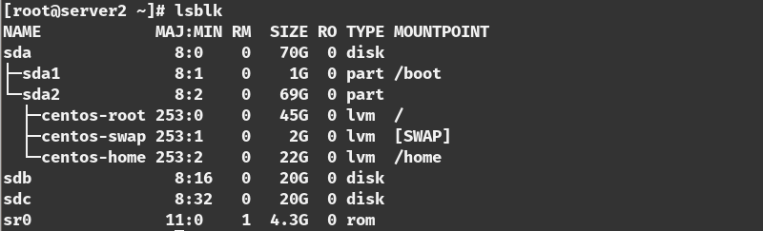
There are two additional block devices name ‘sdb’ and ‘sdc’ er use this two drie to make a raid 0.

STEP5:
install the mdadm packge

=>yum update
=> yum install mdadm -y

STEP6:
check the version in the of the packages
=> mdadm –version

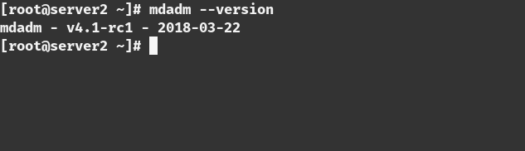
STEP7:
Examine the hard drive with mdadm

=> mdadm –examine /dev/sd[b-c]

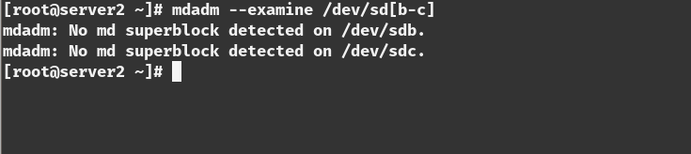

STEP8:

Create partition for RAID

=>fdisk /dev/sdb

Follow below instructions for creating partitions.
- Press ‘n‘ for creating new partition.
- Then choose ‘P‘ for Primary partition.
- Next select the partition number as 1.
- Give the default value by just pressing two times Enter key.
- Next press ‘P‘ to print the defined partition.

Follow below instructions for creating Linux raid auto on partitions.
- Press ‘L‘ to list all available types.
- Type ‘t‘to choose the partitions.
- Choose ‘fd‘ for Linux raid auto and press Enter to apply.
- Then again use ‘P‘ to print the changes what we have made.
- Use ‘w‘ to write the changes.

[creating partition]

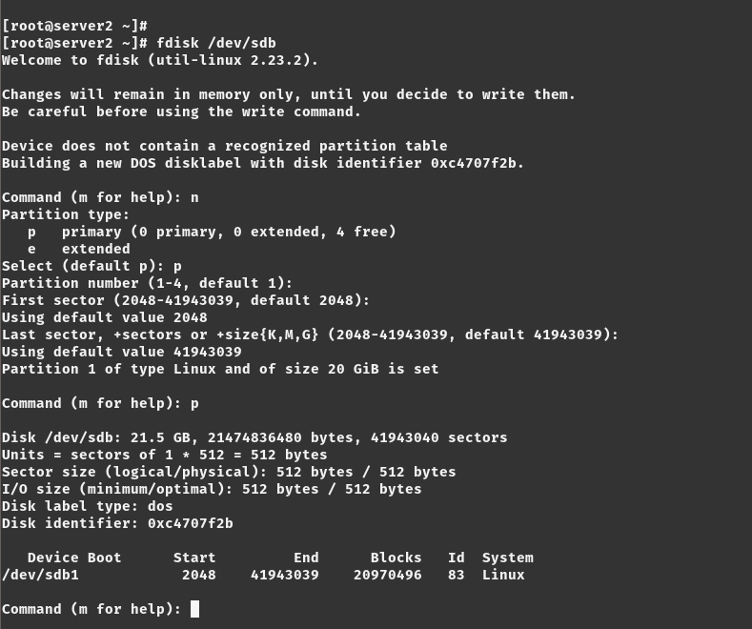

[creating raid on that paririon ]

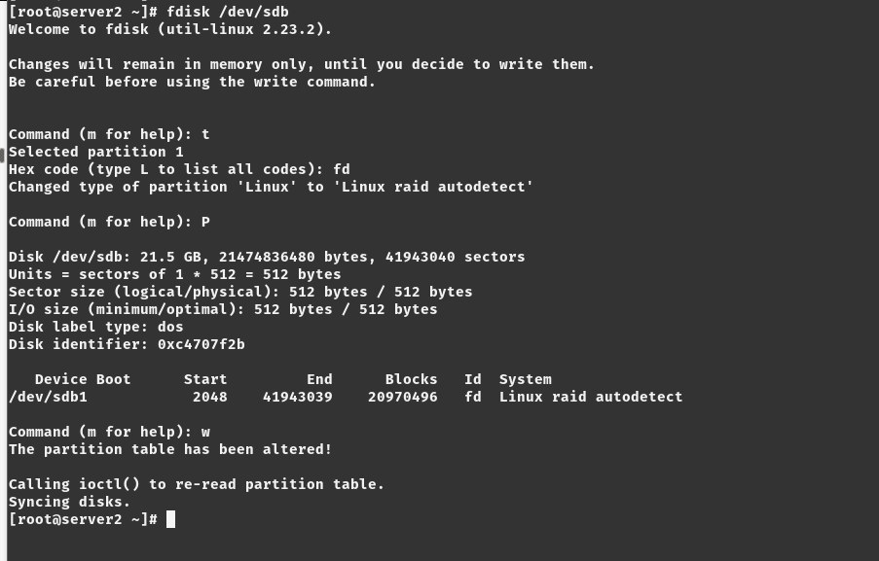
[see the block devices]

STEP9:

Do the step 8 for the ‘sdc’

=>fdisk /dev/sdc

STEP10:

Examine with the ‘lsblk’

=>lsblk

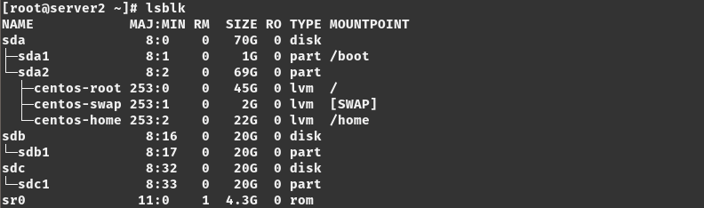

STEP11:

Examine with the ‘mdadm’

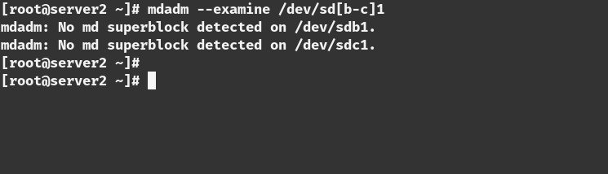
STEP12:

Create RAID md Devices (with miror)

=>mdadm --create /dev/md0 --level=mirror --raid-devices=2 /dev/sd[b-c]1

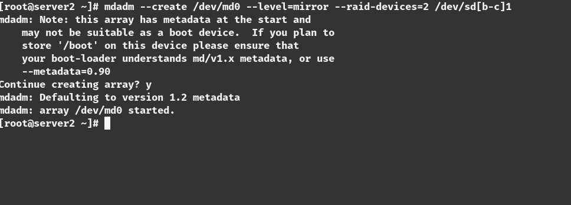

STEP13:

See the Details of the RAID 0 devices

=>mdadm –detail /dev/md0

STEP14:

Assigning File partition on the File system

=>mkfs.ext4 /dev/md0

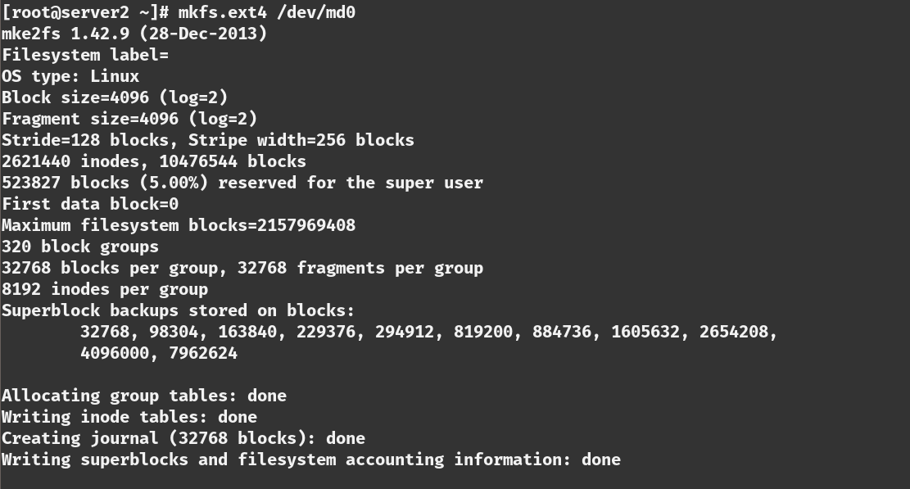

STEP15:

mount the volume

=>mkdir /mnt/raid0
=>mount /dev/md0 /mnt/raid0

STEP16:

check the mounted volume

=>df -h
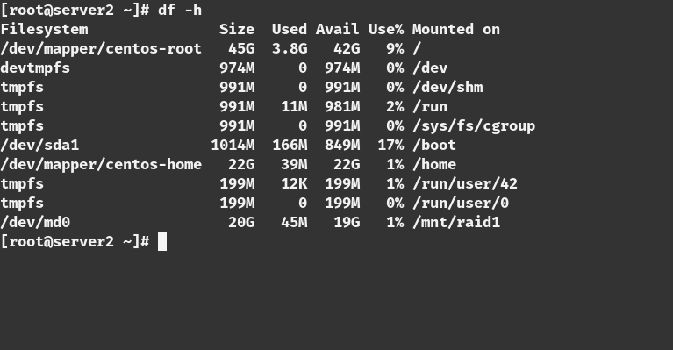

STEP17:

check the block devices with lsblk

=>lsblk

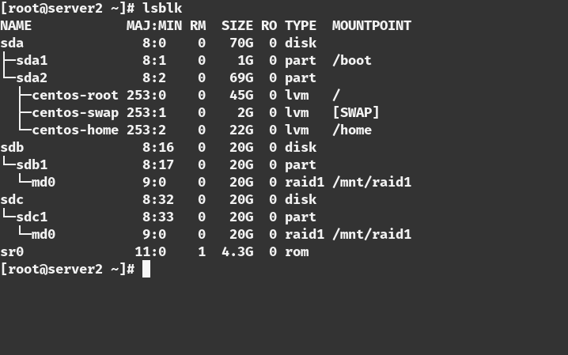

STEP18:

Create a file inside the raid devices. To check that if one device is unplugged if the other have it.

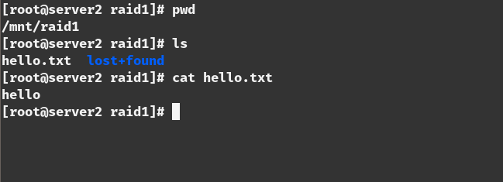
STEP19:
unplug one device

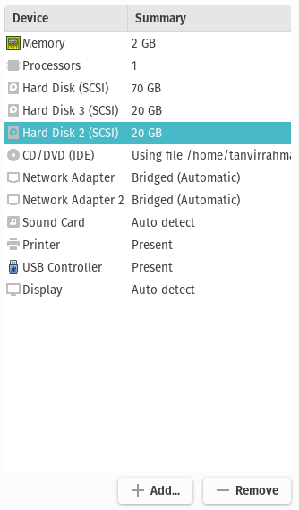

STEP 20:
reboot the system and check the drive that is still connected and see if the backup is still there

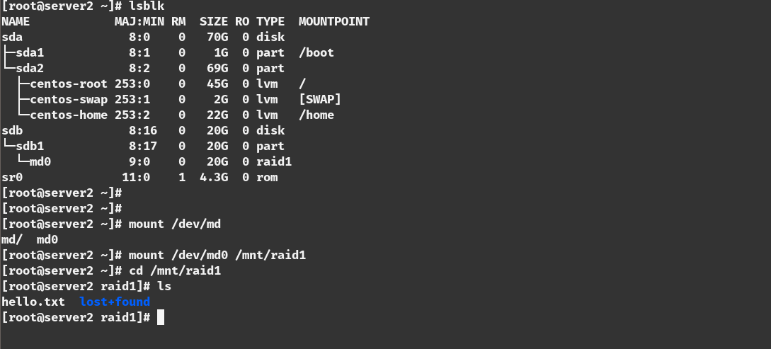

Data is still there even one disk is unplugged

